**Project Log Book**

**Group Members:**

|  |  |
| --- | --- |
| **Entry Date** | **Work Done** |
| September 7th, 2000 | Discussed the basic plan to build the prototype for CRM in class, noting down all constraints to be taken care of. Furthermore, we decided our next group meeting would be on September 15th, 2000 (Friday) at 5:30, meeting place: Zaida Morales' House. |
| September 15th, 2000 | Meeting at Zaida's Place: We discussed about the project objective. Using the Software Management Plan template printed from the web site, we stepped through each section and discussed what was required and what resources were available to us. We also discussed how this prototype should be flexible for other countries. There was constant reference to the "Chinese Railway Passenger Reservation System" and other related articles. |
| September 16th, 2000 | Finished a rough draft prototype and set it up on the online account. |
| September 19th, 2000 | Zaida M. Morales checked the document of the Software Project Management Plan, and she made some correction marking the corrections in red. |
| September 20th, 2000 | The mistakes were corrected on the web site, and email was sent to Zaida M. morales to check the document for any more mistakes |
| September 20th, 2000 | The document was checked by Zaida M. Morales and few more mistakes were found. These mistakes were corrected and put on the web. |
| September 22th, 2000 | Meeting at Zaida's Place: We discussed the Reservation System in more detail and added more information to the SPMP document. |
| September 25th, 2000 | Zaida M. Morales checked the document of the Software Project Management Plan, and she made some corrections. |
| September 27th, 2000 | The mistakes were corrected on the web site, and email was sent to Zaida M. morales to check the document for any more mistakes. |
| September 29th, 2000 | Meeting at Zaida's Place: We discussed parts 4 and 5 of the Software Project Management Plan in more detail and decided to update some information in the SPMP document. The different parts of the document were divided between the team for updates. |
| October 3th, 2000 | Finished updating the rough draft prototype and set it up on the online account. Sent all team members email with link to latest copy of the document. |
| October 4th, 2000 | Zaida M. Morales checked the document of the Software Project Management Plan. The mistakes were corrected on the web site. The latest version of the document is available online. |

***Last Updated on Novemeber 7th, 2000***

**Software Requirements Specification**

*for*

***Automated Railway Reservation System***

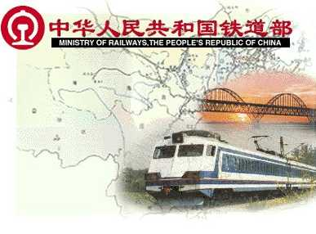

***Huitang Li***

***Vahid Keshmiri***

***Yasin Esmail***

***Zaida M. Morales***

***Natasha Dunaeva***

***Rehan Khan***

***December 04, 2020***

|  |  |  |
| --- | --- | --- |
| Version | Changes Made | Date |
| 1.0 | [First Pass for Review](http://www.geocities.com/cs5391/SRS1.htm) | 10/24/2020 |
| 1.2 | [Second Pass for Review](http://www.geocities.com/cs5391/SRS2.htm) | 11/07/2020 |
| 1.3 | [Third Pass for Review](http://www.geocities.com/cs5391/SRS3.htm) | 11/28/2020 |
| 1.4 | CRM Review Version | 12/04/2020 |
|  | | |

**Table of Contents**

1. Introduction

2. The General Description

3. Specific Requirements

4. Supporting Information

**1. Introduction**

**1.1 Purpose**

This document describes the software requirements for the Automated Railroad Reservation System built for the Chinese Railway Ministry (CRM).

**1.2  Scope In**

The CRM is requesting proposals to build a prototype of an Automated Railroad Reservation System (ARRS) for their current system. This new ARRS needs to be scalable enough so that it can accommodate the increase in reservations caused by new railroad building in China.

The system will be designed to provide an electronic version of the railway passenger reservation system in China. The system will have a user-friendly graphical interface and will be more cost effective compared to the current non-electronic version of the reservation system.

The **objectives** of this development effort are:

1. To provide existing clerks with a new environment in which to make reservations for railroad travel.
2. To provide an avenue for customers to get their tickets in a more convenient way.
3. To regain control of the railway ticket sales to avoid scalping and overselling of tickets.
4. To implement a prototype of a scaled down version of the final system to test the solution and further develop requirements.
5. To collect statistics in a more efficient manner for future railroad development and construction.
6. To increase efficiency of railroads.

**1.3  Scope Out**

The following features will not be the part of this Project:

**1.3 Definitions, Acronyms, and Abbreviations.**

APPM – AsiaPac Marketing Manager

ARRS – Automated Railroad Reservation System

CASE – Computer Aided Software Engineering

CITS – China International Travel Agency

CRM – Chinese Railroad Ministry

PP - Project Plan

SDD - Software Design Description

SRS - Software Requirement Specification

SDS – Software Design Specification

SPMP - Software Project Management Plan

GUI – Graphical User Interface

QAM – Quality Assurance Manager

PDM – Project Development Manager

PMP – Project Management Professional

TBD – To be determined

UML – Unified Modeling Language

**1.4 References**

•       Situation Update – Chinese Railway Passenger Reservation System

[http://www.cs.swt.edu/~donshafer/Marketing Update(1).html](http://www.cs.swt.edu/~donshafer/Marketing%20Update(1).html)

•        China 2000

[http://www.china2thou.com](http://www.china2thou.com/)

•       Pressman, Roger S., *Software Engineering: A Practitioner’s Approach*, McGraw-Hill Companies, Inc., 1997.

**1.5 Overview**

Chapter 2 of the SRS is a brief description of the characteristics of the software to be built, its functions, its users, its constraints and its dependencies.

Chapter 3 is about specific requirements, such as functional requirements, external interface requirements, performance requirements, and also design constraints and quality characteristics.

Finally, chapter 4 includes all the supporting information, such as the Table of Contents, the Appendices, and the Index.

**2. The General Description**

This section describes the general factors that affect the product and its requirements. This section consists of five subsections that follow. This section does not state specific requirements. Each of the subsections makes those requirements easier to understand, it does not specify design or express specific requirements. Such detail is provided in section 3.

**2.1 Product Perspective**

The Automated Railway Reservation System diagram showing the overview of the system’s modules and the relationship of the system to external interfaces is presented in Figure 2.1.

## Figure 2.1 Overview/Architecture Diagram of the ARRS

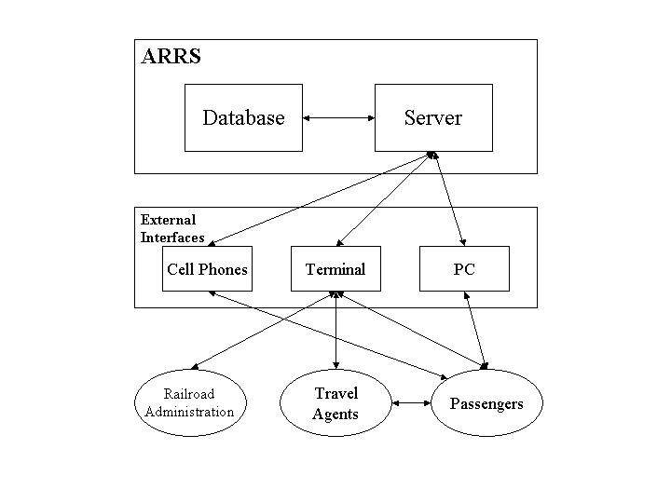

**Functions of System Components:**

Database:

•       Stores data

•       Creates reports

•       Provides access to data

•       Updates information

Server:

•       Provides access to the database

•       Authenticates users

•       Processes reservations

•       Performs backups

•       Produces reports

**External Interfaces:**

Terminal

•       Users use terminals to access the server

•       Passengers and travel agents use terminals to reserve the tickets and to get information about the available seats on particular trains.

•       Railroad administration may use terminals to see the reports generated by the database software.

Personal Computers

•       Users (passengers, travel agents, and railroad administration) may use personal computers to obtain a remote access to the server and the reservation database via the Internet.

Cell Phones

•       Serve as a medium of accessing the server and the reservation database.

•       Passengers may use cell phones and the latest telecommunication technologies to access the server and the reservation database via Internet, or they may use cell phones to call travel agents to inquire about railroad and ticket information.

Computer Hardware and Peripheral Equipment to be used:

•       30 workstations, which include CPUs, monitors, keyboards, and mice

•       Printers

•       Network

•       Terminals

•       Cell phones to test connection to the server via remote access

**2.2 Product Functions**

This section provides a summary of the functions that the software will perform.

**2.2.1 Function Relationships**

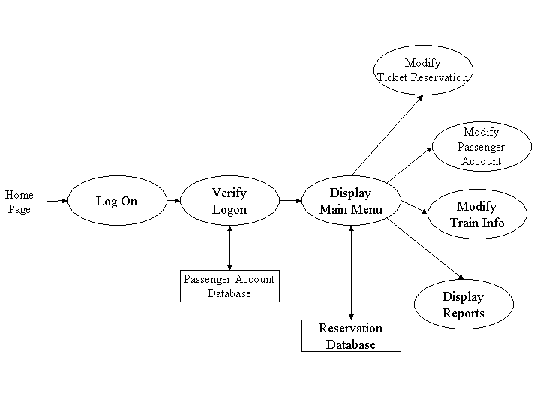Figure 2.2 to 2.6 depict the relationships among the functions to be implemented by the system.  
  
Figure 2.2 ARRS General Function Relationship/**Higher Level Usecase** Diagram

Module 3

Module 1

Module 2

Module 4

**2.2.2 Function Descriptions (Functional Requirement Listings)**

**2.2.2.1 Log In Function**

***Description:*** This function ensures that only authorized users gain access to the Reservation databases. An authorized user is a user who has an account on the system. Users include passengers, train officials, and CRM ministry officials. The user must type a valid username and password to gain access.

**2.2.2 Module 1: ~~Make Reservation Function~~**

***Description:*** This function allows the user to [Make | Drop | View | Update] a reservation for a particular train on a particular date for a certain number of tickets.

If the user does not already have a reservation, then all reservations are dropped. If the user already has a previous reservation, a chosen reservation is dropped from the list of current reservations, and the passenger account balance gets updated.

**2.2.3 Module 2:**

***Description:*** This function

**2.2.4 Module 3:**

***Description:*** This function

**2.2.5 Module 4:**

***Description:*** This function

**2.2.6 Module 5:**

***Description:*** This function

**2.3 User Characteristics**

The main users of the system will be the passengers buying train tickets, the travel agents that process reservations for passengers, and the CRM administration that access the reports generated by the system. The users are not required to have knowledge in the computer field. The graphical interface provides an easy way of using the ARRS system with minimum of training.

**2.4 General Constraints**

The constraints for the project are:

* The functional prototype should be available after 30 days upon the arrival of the management team to China. This may prove to be a serious time constraint on the development of a successful prototype.
* Communication with the Chinese team members may prove to be difficult since some Chinese developers do not speak English and the management team does not speak Chinese. Even with the presence of a translator, communication may be difficult. Absence of the translator may severely affect project development.
* Team members are restricted from bringing their own equipment, and insufficient equipment supply may hinder project development.
* Team members are restricted to bringing only the analysts of the team to China. This might affect the project development if more people are needed or the required skills are not available.
* The majority of the Chinese population does not have or have a limited access to the Internet.

**2.5 Assumptions and Dependencies** **or Business Logic**

The assumptions for the project are:

* Ten trains transport the passengers between three cities known as Guangzhou, Shanghai and Nanjing. These trains originate only in cities Guangzhou and Shanghai, and they make a stop at Nanjing before arriving to their destination.

•       There are five classes of tickets as listed below

* + Sleeping (soft) - compartment style coaches - 4 passenger per compartment
  + Sleeping (hard) - compartment style coaches - 6 passenger per compartment
* Reservation can be made up to one month before a particular trip.
* Seats are assigned during reservation.
* Phone reservation involves tickets being purchased within 24 hours after making the reservation. Otherwise, the reservation will be cancelled.
* No reservations can be made 48 hours prior to the trip. Rather, it will be done on a first come first serve basis from that point on.
* Passenger lists will be provided for conductors at each stop.
* The expected reservations during test period may amount to approximately 25,000 per day. This volume varies by hour, day, and season.
* Chinese Ministry will provide us with information about identification process used in China, so that it can be applied to the reservation system and scalping of tickets is avoided.
* Network connection will always remain established.

## <ADD OOAD REPORT DIAGRAMS HERE>

**3. Specific Requirements**

This section of the SRS contains design requirements for the Automated Railway Reservation System.

**3.1 Functional Requirements**

**3.1.1 Log In Function**

1. ***Description:*** This function ensures that only authorized users gain access to the Reservation databases. An authorized user is a user who has an account on the system. Users include passengers, train officials, and CRM ministry officials. The user must type a valid username and password to gain access.

1. ***Usage Scenario/ Use case Description/******Specification:***

|  |  |
| --- | --- |
| Description | Allows access to online ARRS |
| Inputs | Username, password |
| Source | 1. User inputs username and password 2. Press Login Button |
| Alternate case |  |
| Outputs | Successful login; unsuccessful login |
| Destination | None |
| Precondition | Authorized User |
| Post Condition | No change to Passenger Accounts Database |
| Side Effects | Failures and successful logins are sent to Reservation Database |

1. ***Detailed Use case Diagram for Login: optional***
2. ***Use case Realization for Login: optional***
3. ***Flow of Event or Data Flow Diagram for Login: optional***

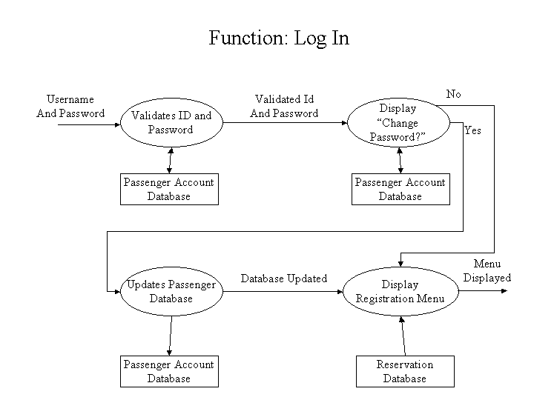

1. ***Sequence Diagram for Login: optional***
2. ***Collaboration Diagram for Login: optional***
3. ***Activity Diagram for Login: optional***
4. ***Class Diagram for Login: optional***
5. ***State Chart Diagram for Login: optional***
   * 1. **Module 1 complete CRUD Make a Reservation Function**

1. ***Description:*** This function allows the user to [make | drop | view | update] a reservation for a particular train on a particular date for a certain number of tickets. If the user does not already have a reservation, then a new reservation is created. If the user already has a previous reservation, a new reservation is added to the list of current reservations, and the passenger account balance gets updated.
2. ***Usage Scenario/ Use case Description/******Specification:***

|  |  |
| --- | --- |
| Description | [ make | drop | view | update] a reservation to the user’s account |
| Inputs | From city, to city, seat type, travel date, return date and time |
| Source | 1. User inputs from city, to city, seat type, travel date, return date and time 2. Press Button … |
| Alternate Case |  |
| Outputs | Added | Deleted | Viewed | Modified reservation |
| Destination | Computer screen  Reservation database  Passenger Account database |
| Precondition | Valid information; train route and tickets available; user does not have another reservation at the same time |
| Post Condition | Reservation added to passenger account |
| Side Effects | User’s current reservations adjusted  Balance due adjusted |

1. ***Use case Diagram:***
2. ***Use case Realization:***
3. ***Flow of Event or Data Flow Diagram:***

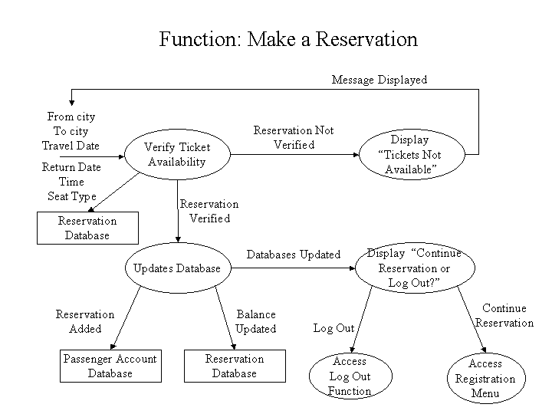

1. ***Sequence Diagram:***
2. ***Collaboration Diagram:***
3. ***Activity Diagram:***
4. ***Class Diagram:***
5. ***State Chart Diagram:***

**3.1.3 Module 3 complete CRUD Make a Reservation Function**

**3.1.4 Module 4 complete CRUD Make a Reservation Function**

**3.1.5 Module 5 complete CRUD Make a Reservation Function**

**3.1.6 Module 6 complete CRUD Make a Reservation Function**

**3.2. External Interface Requirements**

**3.2.1 User Interfaces**

The user interfaces are divided into two major components. One part includes the user accessing the system using a cell phone. The other portion involves accessing the system through a remote site or at a particular location specifically designed to access the system. For instance, the clerks and the CRM access the reservation system from the reservation or CRM office.

The diagrams and explanations below demonstrate the major transition from one user interface to another. This is a brief description. However, a more detailed demonstration is done in the prototype. The purpose of this interaction is to illustrate the overall view of the ARRS.

The diagram below illustrates the four **major functionalities or modules** . These functionalities will be displayed depending on the user. For instance, the CRM will see all four functionalities while the normal user and the clerks will only see the Ticket Reservation and the Passenger Account.

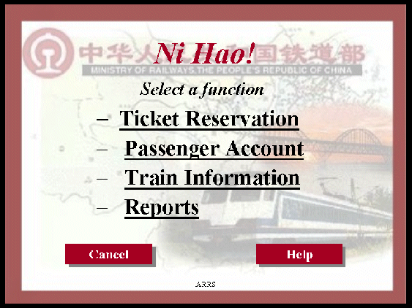

Selecting one of these functions will take the user to a different user interface. For instance, choosing Ticket Reservation will display the following web page. The title of this page is consistent with the function selected, and since the Ticket Reservation was selected, the title displays Ticket Reservation. The purpose of this is to allow the user know what part of the system they are accessing. Furthermore, the user can select any of the four functions.

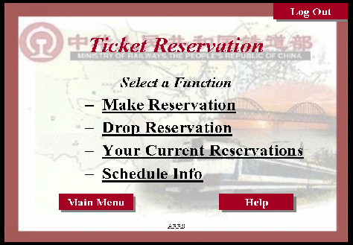

The user can select any of the four functionalities. For the sake of this demonstration, if the user clicks on the Make Reservation function the diagram below is displayed. Once again the title is the same as the main function and a subtitle indicates the second function selected. In addition, the person can fill up the following information and the date of travel or return if he/she wishes. The three buttons allow the user to navigate through the interfaces. For instance, the back button will take the user to the above page, and the clear button will clear the form of any selection he/she made before. The Display Available displays the available trains, seats and what city they want to travel to. However, before we get to the next page when clicking Display Available the picture below illustrates the Make Reservation function.

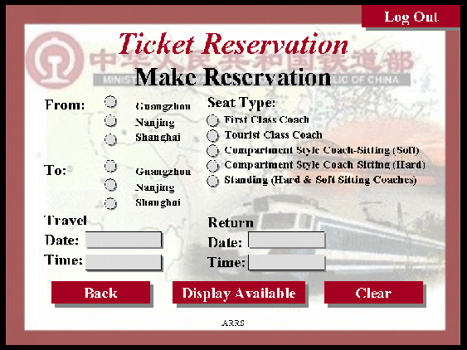

The Display Available function displays all the trains traveling from one city to another and the seats available on that train. Furthermore, the last list displays the number of tickets available for the particular train on the selected route. The back button will take the user to the above picture, and the confirm button takes the person to the payment page.

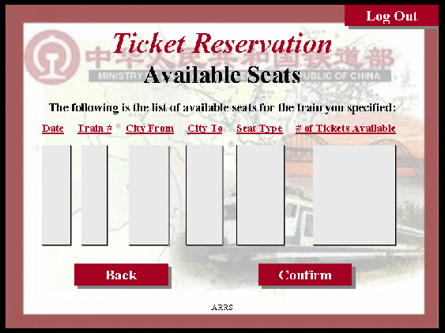

The following page allows the user to pay for the ticket as appropriate. Now, this page is part of the Passenger Account function, and it is used here to make payment for the ticket selected. This makes it easier for the user since they do not have to go back to the main menu and to access their account.

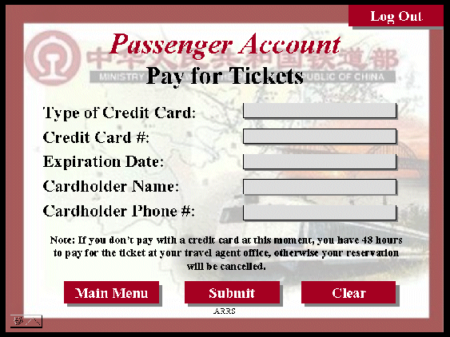

Finally, the submit button displays the appreciation page as shown below with a button to go to the main menu.

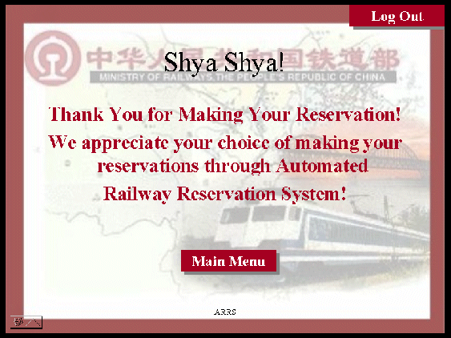

The above illustration has shown a brief overview of the user interfaces involved for the normal and clerk users. However, the CRM have specifically requested a number of reports, and they must be able to adjust their train schedule as the trains become unavailable. Therefore, the CRM interface is able to access all four functionalities as shown in the main menu (first diagram). Once the CRM selects the Reports function, a list of five reports is displayed as linked list. This is shown in the diagram below:

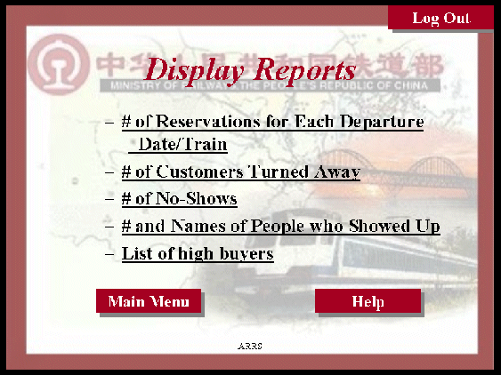

The report selected here shows the number of reservation for each departure. This report indicates the major traffic flow, and what trains are needed where during varying time and season. The diagram below shows the report format to be displayed.

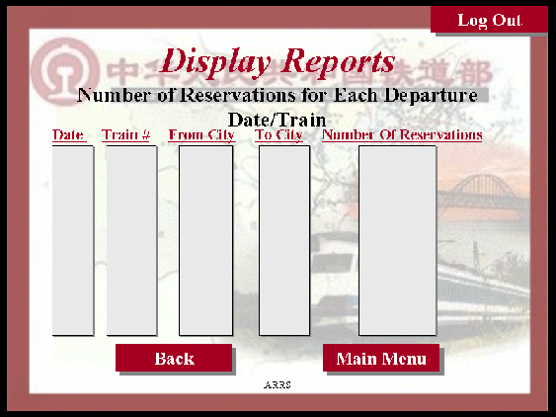

As mentioned earlier, the system can also be accessed through the wireless phones. In that case, the overall system will be the same as the above presentation except that the format will be simplified, since the phones do not have graphic support. The phones will have access to the Make Reservation and Passenger Account, however it is difficult to display the reports and trains information on a small screen for the CRM.

**3.2.2 Hardware Interfaces**

The ARRS includes two major hardware components: cellular phones and regular PC's. The cell phones require WAP (wireless application protocol) network protocol, which is already programmed in the latest phones.

The second component involves the regular PC’s, which communicate with the server. The server then communicates with the database. The protocol involved between the PC's and the server is the HTTP protocol, which allows communication between the PC's and the Server. The remote PC's, such as someone accessing the ARRS from home using the Internet, are able access the information through the CGI. The requests come in through the HTTP protocol, and using an ODBC the database results are returned and processed using Perl to give an HTML web page. The format of the output is displayed as web pages.

**3.2.3 Software Interfaces**

An Oracle DBMS will be used to manage the database and any changes made to it. Furthermore, the DBMS will make regular backups of the database and generate reports regularly so that they can be accessed by the CRM. The Apache server between the client and the database will handle all communication, and the server will run on a Linux operating system. Furthermore, the HTML pages must be implemented such that they can be displayed on two common browsers: Netscape and Internet Explorer.

Information about the products used for the ARRS:

(1) Name: Oracle

(2) Mnemonic: Oracle

(3) Version Number: ?

(4) Source: Oracle

(1) Name: Linux

(2) Mnemonic: Linux

(3) Version Number: 6.2

(4) Source: Unix

(1) Name: Internet Explorer

(2) Mnemonic: IE

(3) Version Number: 5.00

(4) Source: Microsoft

(1) Name: Apache

(2) Mnemonic: Apache

(3) Version Number: 1.3.14

(4) Source: Apache Software Foundation

**3.3 Performance Requirements**

The following sections list the performance requirements for the system.

**3.3.1 User Requirements**

|  |  |
| --- | --- |
| User Requirements | **Description of Requirement For Design Environment** |
| Location(s) and Number(s) of Users | Guangzhou, Nanjing, Shanghai |
| Expected Growth in Number of Users |  |
| After 1 Year | 50% |
| After 2 Years | TBD |
| After 3 Years | TBD |
| User Expectation |  |
| Interactivity | User expect that it provides a very easy to use graphical user interface |
| Reliability | For some applications, reliability must be 100% during the application session |
| Adaptability | Network must adapt to user additions, deletions and changes |
| Security | Encryption software would be used for Credit Card transactions |
| Cost / Funding | Less than $250K |

**3.3.2 Application Requirements**

Since no specified service is indicated, then we have listed the applications as best – efforts. This may change as we learn more about the application.

The communication package is determined to be bursty in nature, with small data sizes and frequent transmissions. We can consider this application to be interactive-burst, while the database transaction-processing application is described by the CRM as transferring large amounts of data (initial estimates are 1 MB/transaction), we have listed this application as interactive-bulk.

|  |  |  |
| --- | --- | --- |
| Categorizing  Applications | Best-Efforts | Application  Locations |
| Communication | 100 Kb/s | Guangzhou and Nanjing |
| Database Access | 400 Kb/s | All Locations |
| Database Transaction processing | 1.5 Mb/s | All Locations |

**3.3.3 Host Requirements**

|  |  |  |
| --- | --- | --- |
|  | Type of Host or  Equipment | Numbers and  Locations |
| Host A | PC | Guangzhou (10), Nanjing(7), Shanghai(10) |
| Host B | Database Server | Shanghai |
| Host C | Application Server | Nanjing |

**3.4.1 Standards Compliance**

There are no design constraints that can be imposed by other standards limitations.

**3.4.2 Software Limitations**

•        must be able to run Internet Explorer or Netscape Communicator web browsers to access the system.

•        must have cell-phone web based capability to access the system from a mobile phone.

**3.4.3 Hardware Limitations**

•        Input/Output: One or two-button mouse, keyboard, cell-phone, or touch screen required.

•        Network card required at thin-client terminals to make communication with server possible.

**3.5 Quality Characteristics**

There are a number of quality characteristics that apply to the ARRS software system.

**3.5.1 Portability**

The ARRS system will be developed using HTML and Java so that it can be accessed from any type of system using just a regular web browser. It will also be available to users that have web access on their cellular phones. The system will be tested on all types of hardware before being released to ensure that is it compliant with this requirement.

**3.5.2 Reliability**

The system should be capable of processing a given number of reservations within a give time frame with no errors and the system should be available and operational all the time. During the development of the prototype for the 3 cities, the system will be tested in its actual environment to ensure that it can handle the load of reservations that occur during a regular workday.

**3.5.3 Usability**

The ARRS system will be developed so that it is an easy to use system that requires the least amount of user input possible. Every input will be validated. The user should only have general computer use knowledge. Error messages will be displayed if the user enters an invalid value or tries to access a function without the required permissions. An easy and well-structured user manual will be provided to the CRM and the system will include descriptive help for all operations allowed.

**3.5.4 Correctness**

The ARRS system will be considered correct when the CRM approves the prototype presented and agrees that all the functions they require are implemented as stated in the Software Requirements Specification.

**3.5.5 Flexibility**

The ARRS system should be developed in such a way that it is easily customizable. If new functions are required by CRM, there will be little effort required to update the system to support new cities or new transactions.

**3.5.6 Security**

The ARRS system should not compromise the customer information at any time. The user information will never be sold to other parties and will be kept secure at all times. Users will be authenticated to ensure that no unauthorized users gain access to private information.

**3.5.7 Maintainability**

The ARRS source code will be kept well structure and documented so that it is easier to maintain and extend the system. All changes to the system shall be documented.

**3.6 Other Requirements**

Certain requirements may, due to the nature of the software, the user organization, etc., be placed in separate categories such as those below.

**3.6.1 Data Base**

The Automate Railway Reservation System will have two main databases. One is the Reservation Database, and another is the Passenger Account Database. These database will be created with Oracle8i (Client/Server) version 8.1.6.0.0 Release 2. The following are the requirements for these databases that are to be developed as part of the product. They include:

**Reservation Database**

|  |  |
| --- | --- |
| Types of information | Schedule information for the trains, including date, time, departure city, destination city, ticket cost and ticket availability for a particular train |
| Frequency of use | Depends on the passenger demand, which may reach 25,000 per day during peak periods |
| Accessing capabilities | The database should allow access to at least 1,000 people at once; the users will have a general access to the information about the train schedule, and a secure access to the reports (available only to CRM officials) using a username and a password |
| Data element and file descriptions | To be determined |
| Relationship of data elements, records and files | To be determined |
| Static and dynamic organization | To be determined |
| Retention requirements for data | Train schedule information will be available as long as the train for a particular route is in use and at least one year after the train has been cancelled. The reports information will be available at least for 5 years |

**Passenger Account Database**

|  |  |
| --- | --- |
| Types of information | Passenger account information including their name, address, phone numbers, last reservations, balance owed, credit card number (if they paid by a credit card) |
| Frequency of use | Depends on the passenger demand, which may reach 25,000 per day during peak periods |
| Accessing capabilities | The database should allow access to at least 500 people at once; the users will have a secure access to the database using a username and a password |
| Data element and file descriptions | To be determined |
| Relationship of data elements, records and files | To be determined |
| Static and dynamic organization | To be determined |
| Retention requirements for data | Passenger account will be available for as long as a passenger is using the account, and at least for 6 month since the passenger logged on last time. |

**3.6.2 Operations**

The normal operations required by the user can be viewed as the following:

User-initiated Operations:

These operations include the login operation, which is initiated by the users. Also, the process of becoming a new user is in this category. Building, changing, and viewing itineraries, as well as paying for the itinerary are all initiated by the users. The user initiates the report generation activity, as well as changing train schedules.

Interactive Operations and Unattended Operations:

The users initiate all the operations mentioned above, and almost all of them are somehow interactive. Displaying the train schedule is non-interactive. The report display is a non-interactive operation, although selecting the desired reports will require user input.

Data Processing Support Functions:

The user account data is used to create new accounts, as well as to validate user id's during login functions. For building itineraries, user input, user account data, and train schedule data are used, and processed. User data along with final results of user interaction (whether the user purchased a trip, number of tickets bought, etc.) are collected, and used for report generation purposes. Administrative users' inputs are collected in order to modify and present schedules.

Backup and Recovery Operations:

Both databases used (passenger account database and reservations database) are production databases. The main operation used for the backup and recovery is Oracle's built-in cold backup, which is also known as the "archive mode". Depending on the customer's needs and budget, additional redundancy can be added using systems like RAID 5 and tape backup.

**3.6.3 Site Adaptation Requirements**

There are no site adaptation requirements for this project.

**4. Supporting Information.**

There is no supporting information required for this project.